BASIC MEDITATION AND PRAYER RETREAT
presented by Mile Hi Church and Dr. Roger W. Teel

Purposes, Instructions and Policies

About This Retreat
The primary purpose of the Meditation and Prayer Retreat (MAP) is to enhance prayer and meditation practices and to advance our conscious awareness of the Divine Presence within us all. It is an opportunity to remove oneself from the distractions, demands and preoccupations of daily life so that awareness may expand and a more intimate connection with the Divine Indwelling may develop.

Several versions of this retreat, of varying durations, are offered. The key spiritual practices are sitting and nature walk meditations, periods of silence, contemplative and affirmative prayer, as well as spiritual teachings and discussion. However, each retreat is also allowed to evolve and to develop its own unique essence. The quiet mind state and resulting awareness of the Divine Indwelling will invite the retreatant to develop a continuing practice of meditation and prayer.

To attend this retreat is to give oneself an array of exquisite and significant gifts: the gift of a keener sense of the spiritual Self…the gift of inner healing that deep silence can initiate…the gift of interior balance and centeredness…the gift of a more open heart… the gift of awakening more fully to the vast dimensions of personal potential…the gift of the “peace that passeth all human understanding”…and the gift of a MAP for the future.

About Lodging
The Franciscan Retreat Center near Colorado Springs offers a marvelous setting for the MAP Retreats. Maximum capacity is 69 retreatants. This venue provides relaxing native trails which provide opportunity for meditative walks and beautiful views of Mount Cedar, Mount St. Francis, the Rampart Range of the Rockies, and offers an outdoor labyrinth and frequent visits by deer. However, while very comfortable, this is not a resort. It is a conference and spiritual center.

Lodging features double occupancy rooms with single beds and a private bath. Two of these are handicap accessible rooms. There are several less expensive rooms that either share a bathroom with another room or contain three single beds. Unless a preference is indicated on the signup sheet, a roommate of the same gender will be assigned. We will make every effort to accommodate your room request on the registration form if the rooms are available. Note: single rooms are not available. Also, rooms are not air conditioned, they have ceiling fans, portable fans and windows.

Rooms are simple but comfortable. There are no hairdryers but there is one to borrow.

Special notice:
Please do not contact the Franciscan Retreat Center directly for any room changes. All room changes must be approved and arranged by Mile Hi Church. This includes the day of arrival.

HOW TO APPROACH THIS RETREAT: You are invited to embrace your MAP Retreat with a purposeful and monastic approach. Attend this retreat in the context of being an individual. You may be accompanied by your spouse, partner, friend, etc., but please place yourself in the space of being “alone with Spirit.” Step beyond tending to relationships and plunge into the gift of connective time with yourself and your God.

About Meals at the Retreat Center
Please note: During this advanced retreat, we will be eating a purely gluten free vegetarian diet.

The menu will feature salads, nuts, grains, and nutritious warm meals utilizing plant-based proteins, veggies and other protein sources such as tofu, tempeh, etc. The menu is designed to supply all the normal proteins, minerals and fiber.

If you choose to supplement this menu, you may choose to bring additional food, protein powder, etc. Several microwaves will be available for you to use. You will also have access to a refrigerator in a designated area.

About Preparations and Logistics
- Check-in begins at 1:00 pm. Please plan to arrive no later than 1:30pm on the day the retreat begins. The first session of the retreat begins at 2 p.m. sharp. Please be aware that you may not be allowed to check into your room until after the initial session if you do not arrive by 1:30.
- It is highly recommended that participants take off work on the initial day of the retreat so as to allow for a leisurely morning and peaceful travel to the center.
- On the concluding day, the last session ends at noon. Check out from rooms is 9:00 a.m.
Note: Lunch will not be served on the last day.
- Sleeping rooms are a short walk from the meeting rooms.
There is limited phone reception, so please leave your cell phone in your car—or better yet, at home. We encourage “unplugging” from all devices during your retreat. You are giving yourself the gift of a deep dive into inner spaces. Thus it is best to delete outer distractions and to stay off internet, email and social media. Note: No cell phones are allowed in the meditation room at any time.
The emergency contact is: Karen Thomas, 303-726-1098.

WHAT TO BRING:
- Personal toiletry items, including shampoo and hair dryers, if desired.
- Loose, very comfortable clothing…and layers. The center is at an elevation of 6800 feet, so plan for many different temperatures.
- Ear plugs (so that we may hold our fellow retreatants in highest compassion)
- Optional: You may want to bring a light blanket or throw for warmth during our meditation sessions.
- A small flashlight...and a travel alarm clock if you sleep deeply
- If needed: cough drops or suppressants, digestive aids, allergy and prescribed medications, vitamins/supplements, etc.
- A water bottle and/or bottled water if you choose. Remember, it is important to remain hydrated at higher elevations and in the process of spiritual practices.
- You are encouraged to bring a journal or notebook to record notes and personal insights.
- Conference chairs can be uncomfortable for long sittings, so you are encouraged to bring a small pillow or meditation cushion for the chair or for sitting on the floor. NOTE: Floor chairs and meditation stools or cushions of various sizes are available on line or by order through many spiritually oriented stores, such as the Works of Heart at Mile Hi Church.
- Shoes suitable for gentle hikes.
- Please leave valuable jewelry at home.
- Optional: slippers, thick socks or crocks, etc., for added comfort during sessions. Please, no bare feet.
- Avoid bringing distractions, such as IPods, laptops, puzzles or Sudoku, etc.
- MOST OF ALL: Bring an open mind and a willing spirit!

About Retreat Policies
- No alcoholic beverages are permitted during the retreat.
- As the Franciscan Retreat Center is private property, it is a marijuana free facility.
- No illegal drugs or paraphernalia.
- No pets are allowed, except for service dogs.
- Suggestions for assignment of roommates will be accepted; however a roommate will be assigned if no preference is indicated. It will not be possible to make rooming changes once assignments are made.
- Special dietary needs must be noted on the registration form. The Center will seek to support these requests as reasonable and possible. Please bring any specialized or highly unique food items or snacks, if you require them.
- Candles or incense are not permitted in sleeping rooms.
- It is recommended that perfumes or colognes NOT be used during retreat.
- No smoking is permitted in any building. Smoking outdoors is allowed only in designated locations.
- All participants must use lodging in the conference facility. RVs, as well as other off-site rooming or camping arrangements, are not allowed.
- Retreat deposit is non-refundable.
- Cancellations:
Should you choose to cancel your participation in this retreat, one of the following provisions will apply:
- If your retreat has a waiting list, and we are able to find a participant to take your place, your retreat payment will be refunded minus the deposit.
- If we are unable to fill your place in the retreat, the church will need to recoup food, lodging and miscellaneous costs that will be still be incurred due to your reservation. Funds beyond these costs will be refunded.

Pre-Retreat Affirmation

I open myself to my spiritual possibilities. I accept that my Meditation and Prayer Retreat is enhancing my total awareness and blessing me with greater wisdom, guidance, compassion, centeredness, peace, and joy. I am absolutely willing to surrender myself to the Inner Silence and to the Infinite Presence. This is just the right experience for me…and I am profoundly grateful! And so it is!

Remember

Registration begins at 1:00 p.m. on the first day of the retreat with check out at 9 a.m. on the final day. The retreat will end at 12pm on the last day and lunch is not included. Participants arriving late may not be admitted into the initial session. All lodging and meals are provided.

DRIVING DIRECTIONS
To The Franciscan Retreat Center

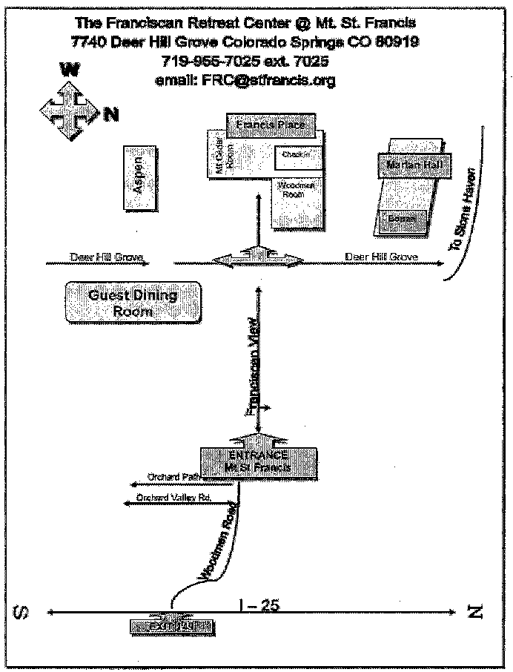

- Take I-25 South from Denver to Woodmen Road (exit 149): Exit West (towards mountains) on to Woodmen Rd.
- At the second light, turn right and continue on Woodmen Rd (3 ~ 3.5 miles) to the entrance of Mt. St. Francis. (Immediately after Orchard Path Rd.)
- Turn left on to Franciscan View Rd. Enter the grounds and follow the directional signs to the Franciscan Center.

